### Lesson 1: Create a Workstation

**Details:** You need to have a workstation to attach an entry point to in the future. Every Entry Point will need a workstation to attach to

* Create three workstations for each Center, called “Front Desk (Center 1 Name)” Front Desk (Center 2 Name), Front Desk (Center 3 Name)
* *Tip: Administration > System Settings > Workstations*

### Lesson 2: Configure Pass Number

**Details:** While configuring the membership settings, assign a pass number with 9 total numbers

* Configure the number so that the first 3 digits reflect the name of your city (e.g., Vancouver --> VAN000002). This ensures membership cards from neighboring organizations will not validate at any of the clients locations.
* *Tip: Administration Tab > Membership Settings > Configuration*

### Lesson 3: Develop Entry Points

**Details:** Develop separate entry points for each of your centres. Entry points represent the locations in which a membership card can be scanned.

* Each entry point should be developed as an individual facility (i.e., “front desk”), and should be tied to a particular centre
* Note: To develop new facilities, go to Administration < Reservation Settings > Facilities
* *Tip: Administration Tab > Membership Settings > Configuration*

### Lesson: 4: Attaching Entry Points to Workstations

**Details:** Entry points need to be attached to workstations previously created

* Attach all entry points to workstations created in Lesson 1

### Lesson 5: Develop Custom Questions

**Details:** While configuring membership settings, integrate a set of custom questions that must be answered before the membership is processed

* Create one free form question revolving around health concerns that the organization should be privy to prior to selling to a customer
* Create another question pertaining to the customer having any special needs which would need to be addressed by the organization
* Create a “How often do you go to the gym” with drop-down options and an option for ‘other’ that adds a free form section
* *Tip: Administration Tab > System Settings > Custom Questions*
* **Custom Questions:** Questions that are created which can be applied to particular workflows – requiring the customer to answer a series of questions before completing a transaction.

**Note:** Use the Chart on the Page below to help complete subsequent lessons in this section

* Each of the charts illustrate a particular membership category, and how to extrapolate membership costs based on certain factors

*Annual, Family, and*

*Auto-renewal memberships get access to all 3 city centres*

***Category 1 - Annual: Access to all 3 city centres***

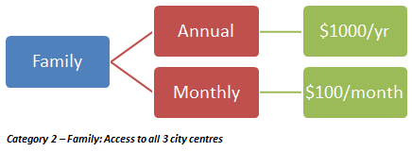

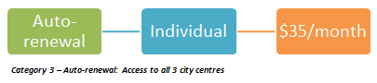

*Punch Pass memberships only get access to the centre where the pass was purchased*

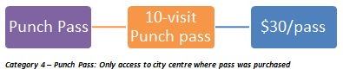

### Lesson 6: Develop Package Categories

**Details:** Develop package categories using information from above charts

* Create each of the four categories (Annual, Family, Auto-renewal, Punch Pass) and include a description for each category
* Ensure that all appropriate check boxes are filled, as per the category
* *Tip: Administration Tab > Membership Settings > Package Categories*

### Lesson 7: Develop General Charges

**Details:** Create charges that reflect the membership charts, with settings configured appropriately

* Deposit fees collected from charges into a GL Account titled: Membership Fees
  + Administration > Financial Settings > GL Accounts
* Describe the charge, select a unit of measure and enter the default fee. Additional fields will be explored later.
* *Tip: Administration > Membership Settings > Charges*

### Lesson 8: Configure Pass Layout

**Details:** Develop the layout of the membership passes by configuring the pass layout settings

* Design the pass so that it contains necessary membership information and city logo
* *Tip: Administration Tab > Membership Settings > Pass Layouts*

### Lesson 9: Create Individual Packages

**Details:** Using the membership charts, create packages for each type of membership

* The membership charts also illustrate where each package is valid for use; ensure that this is reflected in your packages
* Configure each section appropriately, with the correct charge being applied to each package (once package has been created, select **change fees** in package functions and **add new**)
* Note: Resident and non-resident pricing for annual membership packages can be applied by changing the prefill condition in the package fees
* *Tip: Administration Tab > Membership Settings > Packages*